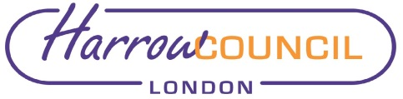

REPORT FOR: | Annual Council
Date of Meeting: | 16 May 2019
Subject: | Information Report - Decisions taken under the Urgency Procedure
Responsible Officer: | Hugh Peart – Monitoring Officer
Exempt: | No

Summary and Recommendations

This report sets out details of decisions taken under the Urgency procedure by Cabinet and the Leader of the Council since the meeting of the Council on 28 February 2019.

FOR INFORMATION

Report
In accordance with Committee Procedure Rule 47.6 set out in Part 4 of the Council’s Constitution, any Executive decisions taken as a matter of urgency are reported to the next available meeting of the Council.

Two such decisions have been taken since the Council meeting on 28th February 2019, the details of which are below:

Subject | Decision Maker | Reason for Urgency
Provision of the Meals on Wheels Service – Hammersmith and Fulham | Leader – 6 March 2019 | A decision was required by 7 March 2019 to allow consultation with staff prior to the start of the service delivery on 8 April 2019.
Property Acquisition | Cabinet – 11 April 2019 | The Council was required to simultaneously exchange contracts and complete the purchase of the property within 25 working days of receiving legal papers from the Vendor.

Where appropriate, Ward Councillors, outside organisations and interested parties were consulted on the individual reports considered by Cabinet and the Leader.

Where decisions were deemed urgent, the agreement of the Chair of the Overview and Scrutiny Committee was obtained that the decision would not be subject to the call-in procedure.

Contact Details and Background Papers

Elaine McEachron, Democratic & Electoral Services Manager
Tel: 020 8424 1097
E-mail: Elaine.mceachron@harrow.gov.uk

Background Papers:
Council’s Constitution
Cabinet report – 11 April 2019
Portfolio Holder Decision report - 6 March 2019

